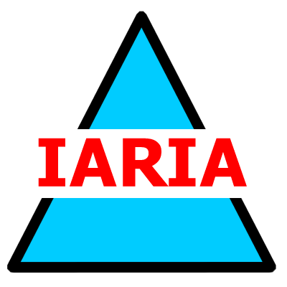  www.iaria.org | The Third International Conference on Software Engineering Advances  ICSEA 2008  October 26-31, 2008 - Sliema, Malta  http://www.iaria.org/conferences2008/ICSEA08.html

Important deadlines:
Full paper submission May 10, 2008
Authors notification June 20, 2008
Registration and camera ready July 20, 2008

Tracks:
- Advances in fundamentals for software development
- Advanced mechanisms for software development
- Advanced design tools for developing software
- Advanced facilities for accessing software
- Software performance
- Software security, privacy, safeness
- Advances in software testing
- Specialized software advanced applications
- Open source software
- Agile software techniques
- Software deployment and maintenance
- Software economics, adoption, and education
- Improving research productivity

