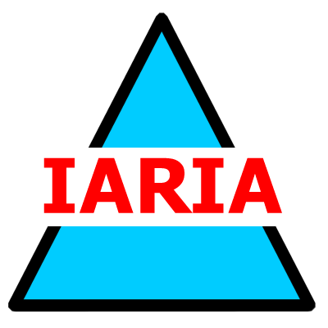  www.iaria.org | The Third International Conference on Digital Telecommunications  ICDT 2008  June 29 - July 5, 2008 - Bucharest, Romania  http://www.iaria.org/conferences2008/ICDT08.html

Important deadlines:
Submission deadline February 15, 2008
Notification March 15, 2008
Registration and camera ready April 15, 2008

Tracks:
- MULTE: Multimedia Telecommunications
- SIGNAL: Signal processing in telecommunications
- DATA: Data processing
- AUDIO: Audio transmission and reception systems
- VOICE: Voice over packet networks
- VIDEO: Video, conferencing, telephony
- IMAGE: Image producing, sending, and mining
- SPEECH: Speech producing and processing
- IPTV: IP/Mobile TV
- MULTI: Multicast/Broadcast Triple-Quadruple-play
- CONTENT: Production, distribution
- HXSIP: H-series towards SIP
- MEDMAN: Control and management of multimedia telecommunication
- SARP: Software architecture research and practice
- STREAM: Data stream processing
- TRACK: Tracking computing technologies

