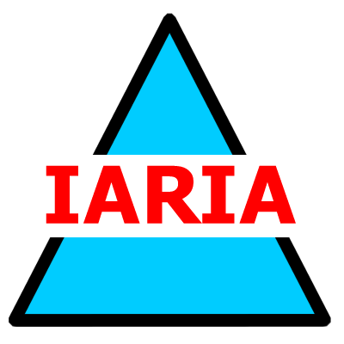  www.iaria.org | International Conference on Biocomputation, Bioinformatics, and Biomedical Technologies  BIOTECHNO 2008  June 29 - July 5, 2008 - Bucharest, Romania  http://www.iaria.org/conferences2008/BIOTECHNO08.html

Important deadlines:
Submission deadline February 15, 2008
Notification March 15, 2008
Registration and camera ready April 15, 2008

Topics:
- Bio-ontologies
- Biocomputing
- Bioinformatics
- Biomechanical devices
- Chemoinformatics

